Document Number | QRP4
Document Title | Management Review Meetings
Department Ownership | Quality & Risk Department
Document Type | Procedure
Department Owner | Derrick Chan
Document Author | Derrick Chan
Last Edited By | Derrick Chan | Lasted Edited On | 02/12/2014

Purpose

The purpose of this document is to describe how Management Reviews take place to ensure control and improvement of the Quality Management System within RediMed

Scope

This procedure shall be applied to all Management Reviews of the Quality Management System that the Quality & Risk Department initiate, and will be either an unscheduled review Meeting to address a limited topic or a scheduled annual management review meeting.

Reference Documents

ISO 9001:2008 Quality Management System – Requirements

Definitions

QMS – Quality Management System
Q&R – Quality and Risk

Flowcharts (Other Images)

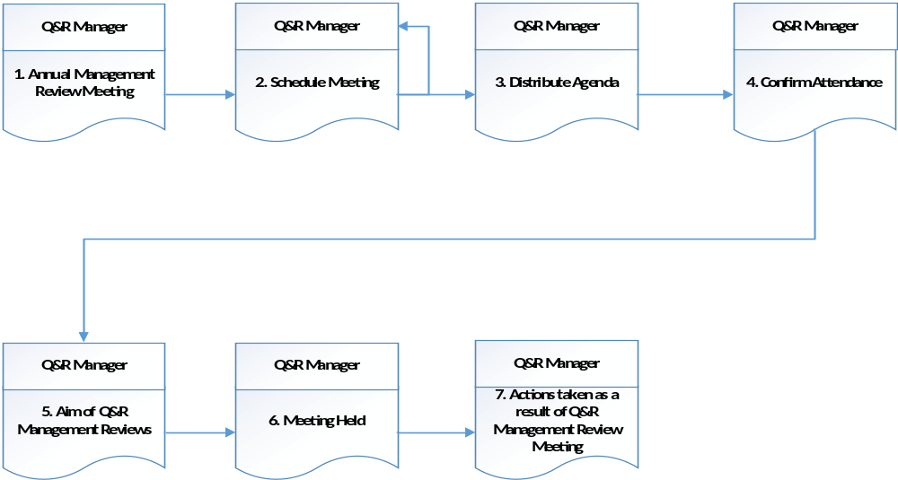

Procedure

- Annual Management Review Meeting

The Q&R department liaises with the certified departments and organizes to conduct Management Review Meetings after an external audit is completed. These meetings are held annually.

At these Management Review Meetings the Q&R department presents data on the internal and external audit findings, and any internal and external PIR’s and Observations raised through the audits conducted. At these meetings any issues or concerns regarding the result of the internal and /or external audits are discussed.

These meetings allow a regular and dynamic review of the QMS to ensure the system continues to meet the business needs

- Schedule Meeting

The Management Review Meetings will be held annually with top management after an external audit is completed

An “unscheduled” meeting may be called at any time and it is to determine without delay the necessary actions arising from audit reports, PIR’s or Observations. For complex issues action may be referred to a special or regular Management Review meeting.

- Distribute Agenda

Send agenda to nominated managers

Reason: Invite appropriate personnel
Output: Agenda
Retention: 2 years

- Confirm Attendance

Confirm attendance of Manager or Delegate with the Q&R Manager

Reason: Ensure relevant personnel represented

- Aim of Q&R Management Reviews

Aims of Management Reviews of the Quality Management System

Review Input:

- Results of audits

- Customer Feedback

- Process performance and product conformity

- Status of preventive and corrective actions

- Follow-up actions from previous Management Review

- Changes that could affect the Quality Management System, and

- Recommendations for improvement

Review Output:

The output from the Management Review shall include any decisions and actions related to:

- Improvement of the effectiveness of the Quality Management System and its processes

- Improvement of products relating to customer requirements, and

- Resources needs

The meeting is held with minutes and action points recorded. These are distributed to all attendees.

Reason: Provide a record of the meeting
Retention: 2 years

- Meeting Held

Distribute minutes of any outstanding items to be addressed in the meeting to all participants and advise them of any actions that need to be taken as a result of the meeting.

- Actions taken as a result of Q&R Management Review Meetings

Relevant managers who are identified on the Action Plan are to complete actions and notify the Q&R Manager when completed.

Reason: Ensure issues raised are resolve

Appendices

QMS Management Meeting Agenda QR10 Template

QMS Management Meeting Minutes QR11 Template

